**East West University**

A

Project Report On

***“Course Management System”***

For the course

***“Object-oriented programming”***

**Submitted By:**

* Md. Monowar Hossain Nibir (2019-1-60-052)
* Sanat Kumer Mollick (2019-1-60-166)
* Minhazul Amin Tomal (2019-1-60-145)

**Submitted To:**

Md. Mohsin Uddin

Lecturer, Department of Computer Science and Engineering

**Introduction**:

Our project is about Course Management System. This project can be used in University for their course advising purpose. Students can take their course by our project easily. We ensure that students and admin don’t face any problem by using this application. We create this project using Java. It totally based on Object Oriented Programming.

**Requirement Description:**

* Computer
* Any operating system
* Any Java Compile App (Netbeans, Intellij, Eclipse)

**Graphical User Interface Snapshot:**

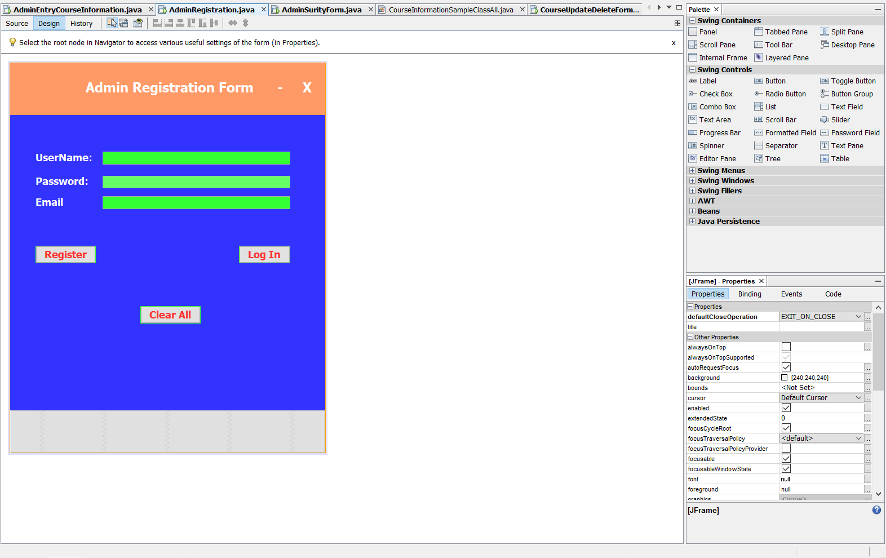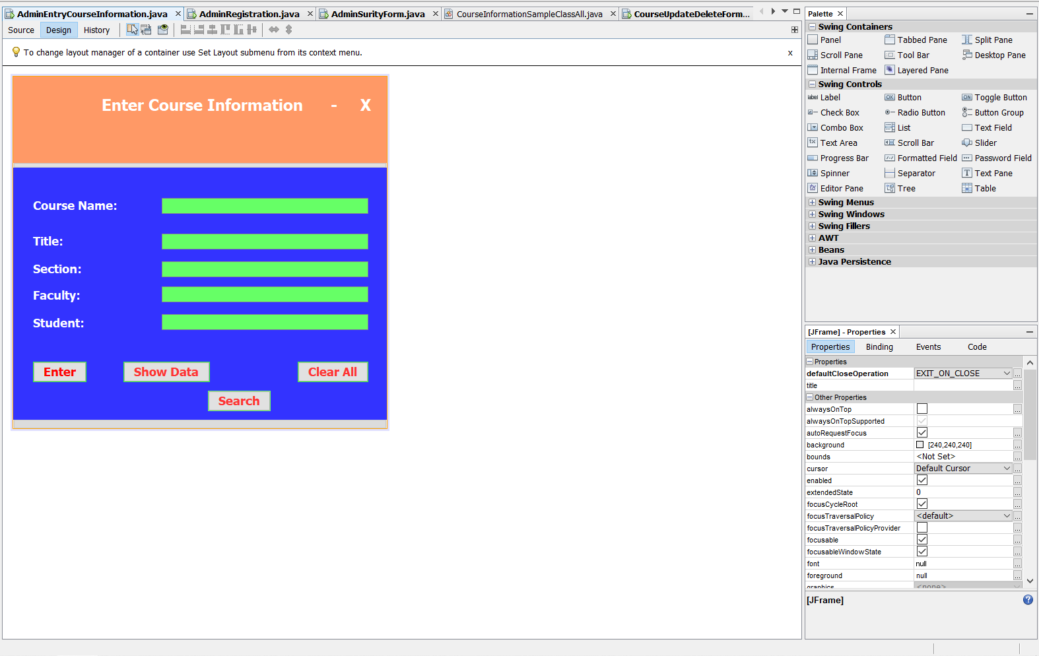

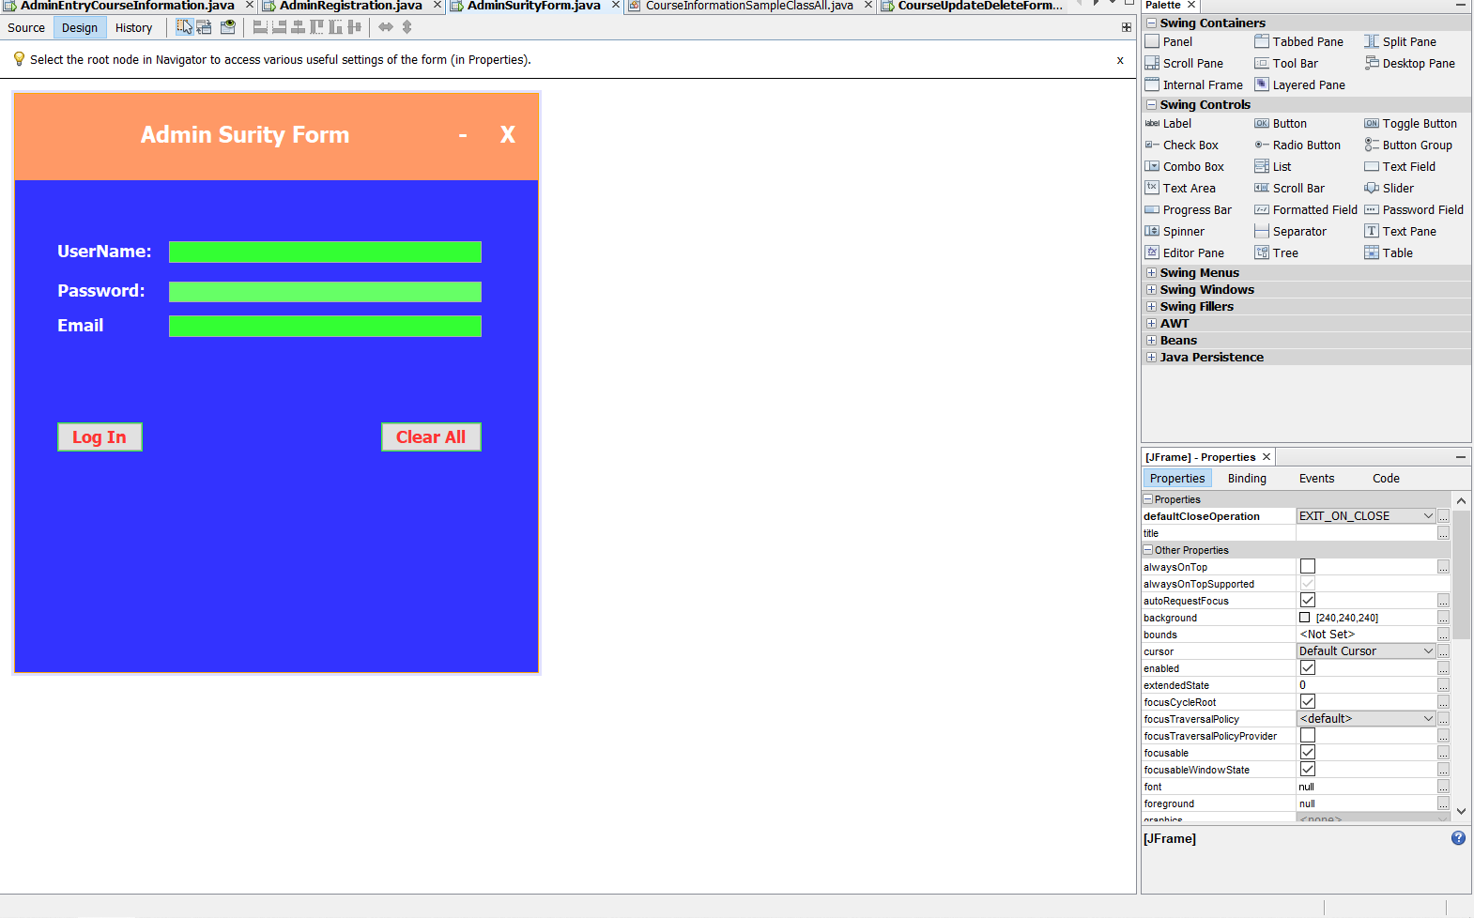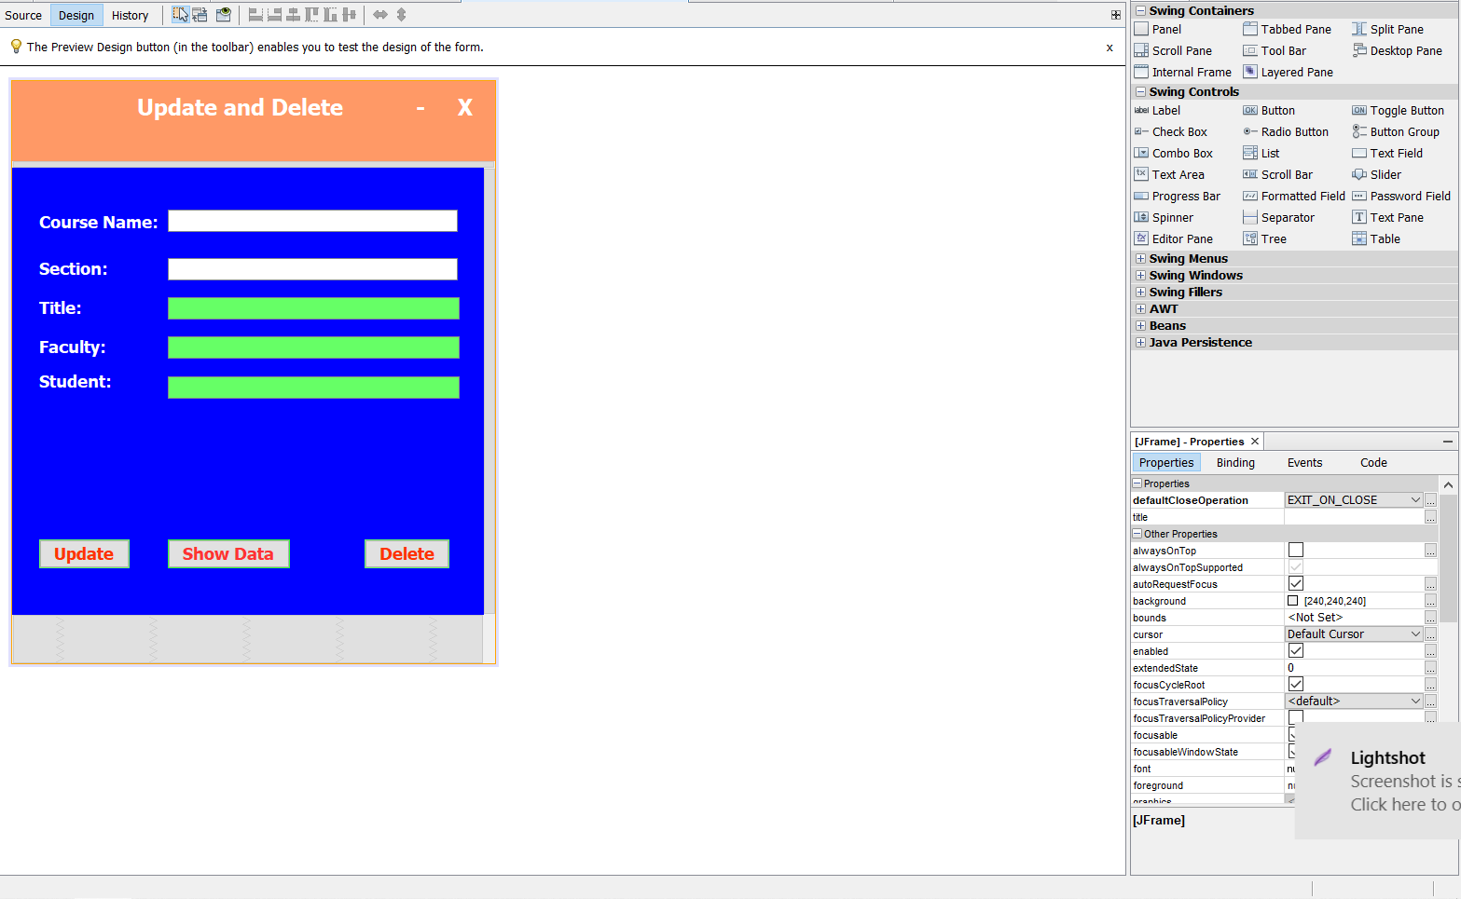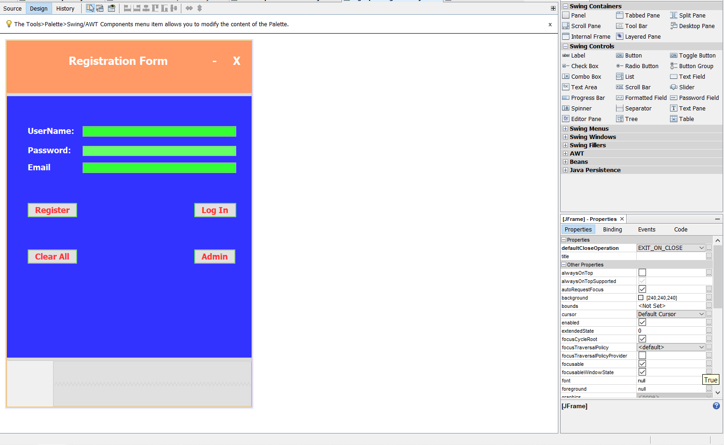

**Sample Input & Output:**

Note: I put a video with zip file for proper review.

Thank You